**456/2**

**MATHS**

**Paper 2**

**Nov**

**2020**

**2 hours : 30 minutes**

**KING’S COLLEGE – BUDDO**

**Uganda Certificate of Education**

**Internal Mock Examinations 2020**

**Paper 2**

2 hours 30 minutes

**Instructions to candidates**

* *Answer* ***all*** *the* ***eight*** *questions in Section* ***A*** *and any* ***Five*** *from Section* ***B.***
* *All necessary working* ***must*** *be shown clearly.*
* *Begin each answer on a fresh page.*
* *Silent, non-programmable scientific calculators and mathematical tables with a list of formulae may be used.*
* *Graph papers are provided*

**SECTION A**

**Answer all questions in the section**

1. Find the Highest Common Factor (H.C.F) of 420 and 780. (04 marks)
2. Without using tables or calculator, evaluate.

÷  (04 marks)

1. Express the decimal number 0.5393939---- as a fraction in its lowest term.

(04 marks)

1. The position vectors of P and Q are and respectively.

Find the;

1. Vector $PQ$
2. Magnitude of PQ (04 marks)
3. Simplify. Give your answer in standard form. (04 marks)
4. Two similar plastic containers have capacities of 0.75 litre and 6 litres. If the height of the small container is 15cm, find the height of the big container.

(04 marks)

1. Dorothy deposited sh. 6,000,000 in a bank. The Bank gives a compound interest of 15% annum. Find the interest she got from the bank after 2 years.

(04 marks)

1. Given that f(x) = 5x+9 and g(x) = $\frac{x-3}{2}$, find ;
2. gf(x)
3. gf(4) (04 marks)
4. find the equation of the straight line passing through the point (5,3) and is perpendicular to the joining the point A(-1, 5) to B(8,2) (04 marks)
5. The diagram below shows a net of a right pyramid PQRST on a square base. The sides of the square base are 48cm each. A is the mid-point $\overline{QR}$ and $\overline{AT}$ = 40cm

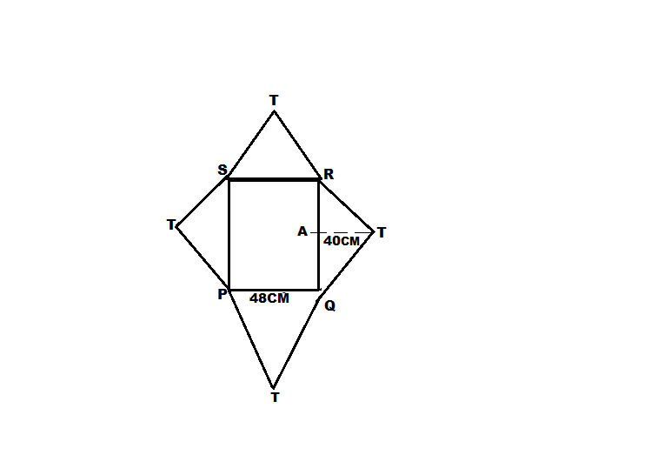

1. Draw a sketch diagram of the pyramid
2. Calculate the height of the vertex of the pyramid from the base.(04 marks)

**SECTION B (60 MARKS)**

1. If h(x) = px+9 and h(5) = 44
2. Find the value of
3. P
4. h(0)
5. h(-1) (08 marks)
6. determine :
7. h-1(x)
8. h-1(51) (04 marks)
9. (a) Three girls Mary, Lonah and Ritah shared sh. 119,000 in the ratio 3:5:9 respectively. How much money did each girl get? (06 marks)

Find the next two terms in each of these sequences:

1. 1, -3, 9, -27,………..
2. 7,10,16,25,………
3. 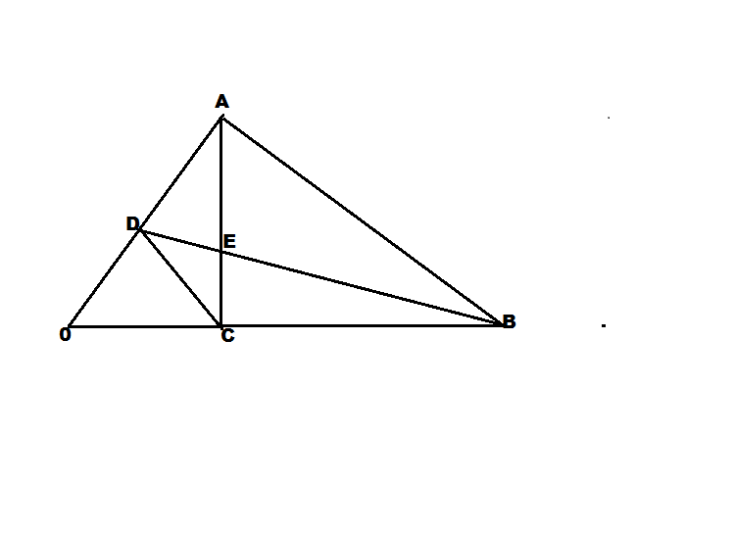The figure below shows a triangle OAB such that $\check{0A }$ = $\check{30D}$, $\check{OB}$ = $\check{30C}$ and E is a point on $\tilde{BD}$ that $\check{BD}$ = $\tilde{4BE}$
4. If $\tilde{OA}$ = $\tilde{a}$, $\tilde{OB}$ = $\tilde{b}$, express the following vectors in terms of $\tilde{a }$ and $\tilde{b}$
$\tilde{BD}$

$\tilde{DC}$

$\tilde{AE}$

5. $\tilde{EC}$ (08 marks)
6. Show that the points A, E and C are collinear (04 marks)
7. In a class of students, 35 play volleyball (V), 39 play Football (F). The number of students who play volley is the same as those who play chess(C ) 13 play volley and football, 11 play Volleyballand Chess. 3 students play none of the games. 16 play chess only while 4 students play all the three games.
8. Represent the above information on a Venn diagram. (08 marks)
9. Determine how many students are in the class. (02 marks)
10. If a student is selected at random from the class, find the probability that the student plays at least two of the game. (02 marks)
11. At 7:00am. Musa sets off cycling from his home at a steady speed of 20kmh-1 to attend a meeting at the District Headquarters 50 km away. At the same time Gloria sets off from the District Headquarters cycling at a steady speed of 15kmh-1 to inform Musa that the meeting was postponed to a later date. At exactly 7:30a.m. Musa gets a puncture which takes him 30 minutes to mend then he proceeds with his journey cycling carefully at 10kmh-1. Using a scale of 4cm to represent 1 hour on the horizontal axis and 2cm to represent 5 km on the verticle axis:
12. Draw a distance time graph on the same axes for Musa and Gloria.(08 marks)
13. Use your graph to determine the
14. The time when Gloria met Musa. (01 mark)
15. Distance from where they met to the District Headquarters.

(01 marks)

1. Time when they were 12.5km apart. (02 marks)
2. The diagram below shows a right pyramid ABCDV on a square base of side 24 cm and slant length 22cm with O as the centre of the base. M and N are the mid-points of $\overline{AD}$ and BC respectively.

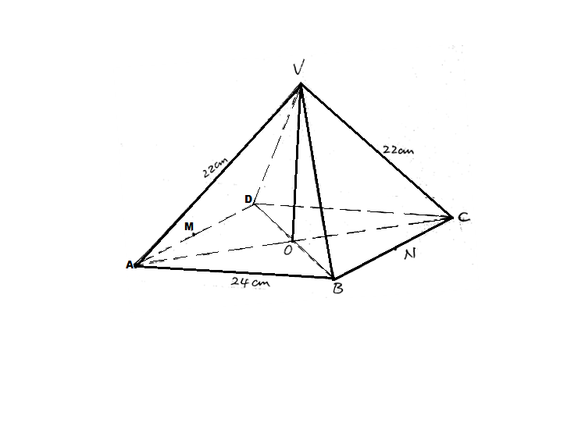

Calculate the :

1. Height of the pyramid (05 marks)
2. Volume of the pyramid (02 marks)
3. Angle between the slant faces ADV and BCV (05 marks)
4. The table below shows the income tax rates of a certain country for government employees.

TAXABLE INCOME TAX RATES IN %

1 – 100,000 6

100,001 – 300,000 12

300,001 – 600,000 15

600,001- 1,000,000 20

1,000,001 and above 60

An employee earns a gross monthly salary of sh. 1,750,000/= which includes the following allowances. Housing allowance 10% of the gross monthly income. Family allowance of 110,000/= and Medical care of Shs. 125,000/=.

Calculate the;

1. Taxable income (03 marks)
2. Income tax paid (07 marks)
3. Percentage of gross salary which the employee pays as tax. (02 marks)

**END**